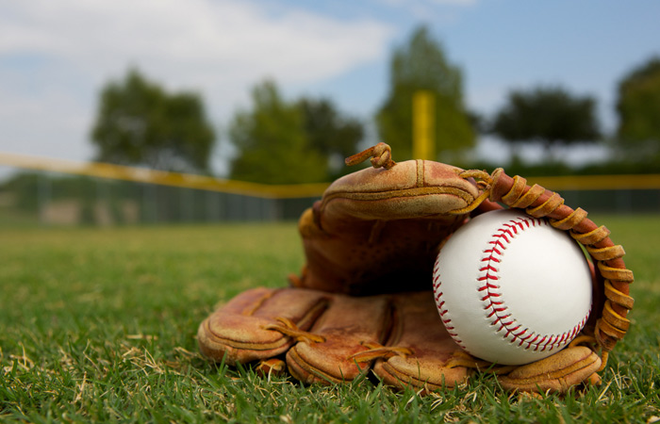
Batter Up!

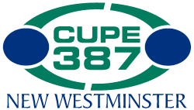

VS

“Play ball!”

When: Thursday June 22nd, 2017; 5:00pm
Where: Queens Park Stadium ballfield

No experience necessary, just enthusiasm and the desire to have fun!

Refreshments courtesy of CUPE 387
So bring your glove along…and “bring it on”!

Email Nancy Jickels at njickels@newwestcity.ca to sign up. Please indicate if you are bringing along additional guests/players as well as whether you are CUPE or Exempt

